**In-Class Exercise Solution**

**January 21, 2014**

***Sailaja Pedaprolu, 16157493***

Assumptions made while designing the UML class and sequence diagrams for the Home security system

* There is one owner and several operators.

Yet, owner is provided with ownerID to enable the login differentiation between operator and owner.

* Operator can only:

1. Turn the system on/off
2. Activate or deactivate the sensors

* Owner can perform the following inclusive of the actions performed by the operator:

1. Set threshold for the sensors
2. Program phone numbers
3. Set delays for various alarms

* Smoke sensor, entry sensor, temperature sensor and flood sensor are the classes inherited from the class – sensor.
* There is a unique alarm tone for each type of input from a specific sensor.

The UML class diagram is as follows:

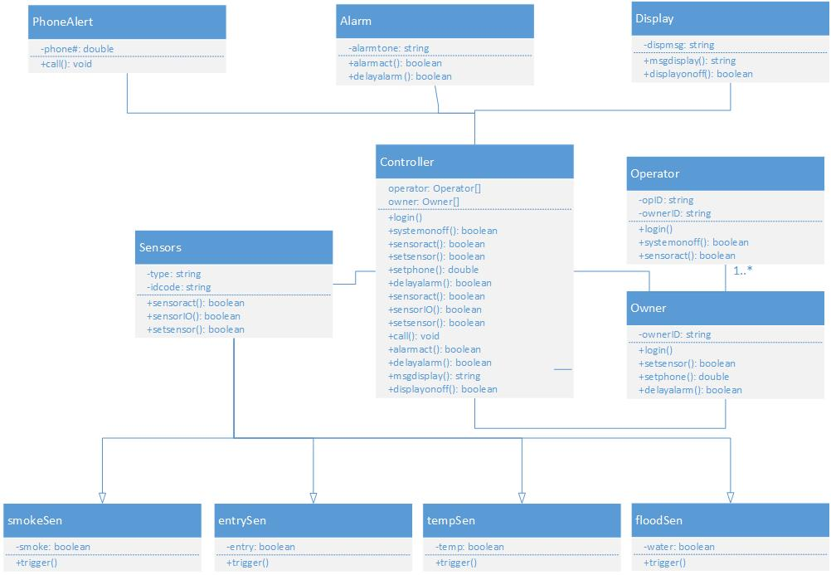

The UML sequence diagram is as follows:

